# Overview

This document logs the step-by-step operations while setting up Activiti on CentOS

NOTE:

1. The version deployed on the current instances may not be up-to-date. Use the following tutorial may install a newer version, which, in the worst case, leads to version incompatibility with the other COTS or scripts. Please refer to the version # in the “Overview of the current infrastructure” and try to install the specified version.
2. Please refer to the “Dependencies” in the “Overview of the current infrastructure” to check any prerequisite for installation.

# Installation

1. From local machine, upload required packages the server
   1. mysql-connector-java-5.1.39-bin.jar
   2. db.properties
   3. activiti-rest.war
   4. activiti-explorer.war

For example,

**scp -i /path/to/USC-Jeff-Key.pem /path/to/required/packages centos@ec2-54-67-99-52.us-west-1.compute.amazonaws.com:~/**

1. Copy the packages to tomcat

**sudo cp ./activiti-explorer.war /usr/share/tomcat/webapps**

**sudo cp ./activiti-rest.war /usr/share/tomcat/webapps**

1. Restart tomcat

**sudo systemctl restart tomcat**

1. Use a browser to visit activiti-explorer and activiti-rest

http://ec2-54-67-99-52.us-west-1.compute.amazonaws.com:8686/activiti-explorer

http://ec2-54-67-99-52.us-west-1.compute.amazonaws.com:8686/activiti-rest

1. Set up a database in MySQL for Activiti

**mysql -u root -pHuaweiUSC;**

**drop database activiti;**

**create database activiti;**

**grant all on activiti.* to 'activiti' identified by 'HuaweiUSC';**

**exit**

1. Set MySql connection for activiti-explorer

**sudo cp ./mysql-connector-java-5.1.39-bin.jar /usr/share/tomcat/webapps/activiti-explorer/WEB-INF/lib/**

**sudo cp ./db.properties /usr/share/tomcat/webapps/activiti-explorer/WEB-INF/classes/**

1. Set MySql connection for activiti-rest

**sudo cp ./mysql-connector-java-5.1.39-bin.jar /usr/share/tomcat/webapps/activiti-rest/WEB-INF/lib/**

**sudo cp ./db.properties /usr/share/tomcat/webapps/activiti-rest/WEB-INF/classes/**

1. Restart tomcat to load the new settings

**sudo systemctl restart tomcat**

1. Try to visit activiti-explorer from a browser, for example

http://ec2-54-67-99-52.us-west-1.compute.amazonaws.com:8686/activiti-explorer

With credential: kermit(kermit)

# Data/Script Deployment

1. Visit activiti-explorer from a browser, for example

http://ec2-54-67-99-52.us-west-1.compute.amazonaws.com:8686/activiti-explorer

With credential: kermit(kermit)

1. Upload BPMN diagrams through Manage Dashboard



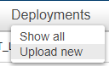

For the latest prototype, only upload the BPMN diagrams from “Data Backup” -> “BPMN from Activiti” -> “BPMN digrams in Activiti.zip” -> “Activities”

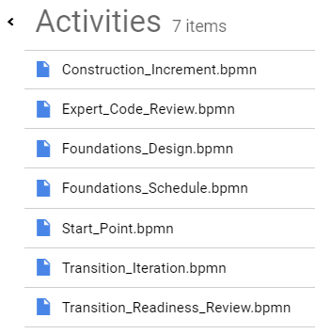

For each diagram, there will be a unique IDs (e.g. sp_ci:1:4143) which can be viewed in the Processes Dashboard

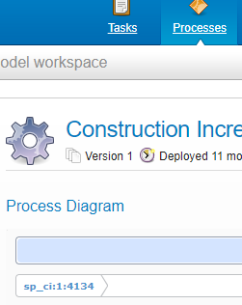

**Record all these diagram names and their IDs. They will be used to setup the main system prototype.**